**Recurrent Neural Network (RNN)**

**Instructions:**

Please share your answers filled in-line in the word document. Submit code separately wherever applicable.

Please ensure you update all the details:

**Name: J.Berger Perkins Batch ID: DSWDMCOD 281022B**

**Topic: Recurrent Neural Network.**

**Guidelines:**

**1. An assignment submission is considered complete only when correct and executable code(s) are submitted along with the documentation explaining the method and results. Failing to submit either of those will be considered an invalid submission and will not be considered as correct submission.**

**2. Ensure that you submit your assignments correctly and in full. Resubmission is not allowed.**

**3. Post the submission you can evaluate your work by referring to keys provided. (will be available only post the submission).**

**Hints:**

1. **Business Problem**
   1. **What is the business objective?**
   2. **Are there any constraints?**
2. **Work on each feature of the dataset to create a data dictionary as displayed in the image below:**

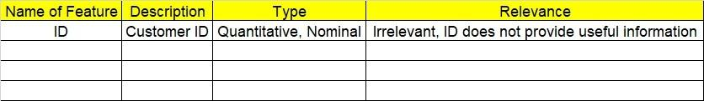**Make a table as shown above and provide information about the features such as its data type and its relevance to the model building. And if not relevant, provide reasons and a description of the feature.**

**Using Python to perform the following:**

1. **Data Pre-processing**

**3.1 Data Cleaning, Feature Engineering, etc.**

**3.2 Outlier treatment.**

1. **Model Building**

**4.1 Build a Recurrent Neural Network.**

**4.2 Train and test the model.**

**4.3 Briefly explain the model output in the documentation.**

1. **Write about the benefits/impact of the solution - in what way does the business (client) benefit from the solution provided?**
2. **Use Tensorflow for this assignment. Depending on your system configuration, use either Tensorflow GPU or Tensorflow CPU versions.**

**Problem Statement: -**

1. Here is the time series data [110,125,133,146,158,172,187,196,210]. Build an RNN/LSTM model to predict the next 10 digits.
2. Write down the applications of RNN.
3. Write about how the inputs are selected for LSTM/RNN models. Explain in terms of timesteps, samples, and features.
4. What are the disadvantages of MLP when dealing with sequence data?